Seminar Organized in the Session 2018-19
TOPIC : “THE VISIT OF GANDHI CHANGED THE POLITICAL
AWARENESS OF ODISHA”
Dated : 04.12.2018
RESOURCE PERSON : MR. BIKRAM KESHARI MOHAPATRA, READER IN HISTORY
SARASWATA MAHAVIDYALA, ANANTAPUR, BALASORE
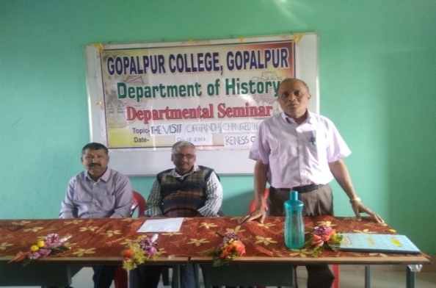
A departmental Seminar on the topic “THE VISIT OF GANDHI CHANGED THE POLITICAL AWARENESS OF ODISHA” was organized by organizing secretary cum faculty member Mr. Prafulla Kumar Behera, Reader in History of Gopalpur College, Gopalpur, Balasore under Presidentship of Naresh Kumar Parhi, the Principal of this College on 4th December 2018 at 11.00 A.M. in the Department Room. Mr. Bikram Keshri Mohapatra, Reader in History of Saraswata Mahavidyalaya, Anantapur addressed the seminar as Resource Person. Other eminent members of the seminar are Mr. Ramakanta Sahu, HOD in History and 38 members were remaining present in this seminar. The objectives of the seminar were Gandhi visited Orissa seven times during freedom struggle and his appearance changed political atmosphere in Odisha.

Topic: “Mystical thoughts in modern Odia poems” ( Adhunika Odia Kabitare Rahasyabadi chintadhara) Dt: 20.09.2018
Resource person Dr. Sarat Chandra Mohanty
The Department of Odia Language and Literature of this college had organized a seminar on the topic Mistical thoughts in modern odia poems on date-20.09.2018. SJ.Naresh kumar Parhi, Principal of the college presided over the meeting. Dr. Sarat Chandra Mohanty, Reader in odia of U.N College , Soro had joined as the chief speaker in the seminar. All faculties and students of the Department had attended the meeting. Dr. (Mrs) Prativa Mohanty, Reader in Odia introcuded the guest in her welcome address. Chief speaker Dr. Mohanty delivered valuable and memorable talk on the topic.Departmental staff Dr. Amarendra Mohapatra and Miss Mamata Barik gave brief description on the theme of the topic. Students of the department took part in the question-answer programme. At the close of the meeting, Miss Anita Jena Lect. in Odia offered vote of thanks and the seminar ended with thanks to the chair. 40 no.s of participants remaining in this seminar.

- Topic : “Post independence Odia dramas” (Swadhinata parabarty Odia Natak) Dt: 19.12.2018
Resource person Dr. Sarat Chandra Mohanty
A seminar Titled Post independence Odia dramas was held in the Department of Odia Language and Literature of this college on 19.12.2018. Sj. Naresh Kumar Parhi, Principal of the college inaugurated the meeting and presided over it. Dr. Sarat Chandra Mohanty, Reader in Odia of U.N College Soro had joined as the chief speaker in the seminar. Departmental sfaff and students had attended the seminar. Dr. (Mrs) Prativa Mohanty, Reader in Odia introcuded the guests in her welcome address and gave a brief introduction under topic. Chief speaker Dr. Mohanty elaborately discussed about the theme. Departmental lecturers Miss Anita Jena and Dr. Amarendra Mohapatra presented their own views under topic. President Dr. Naresh Kumar Parhi told about the stage value and satisfaction of audience in dramas.all the students of the Department took part in the discussion. The meeting ended with vote of thanks by Miss Mamata Barik, Lect. in Odia. 35 no.s of participants remaining in this seminar.

Topic: “Element of absurdity in European Dharma”
Date: 05.11.2018
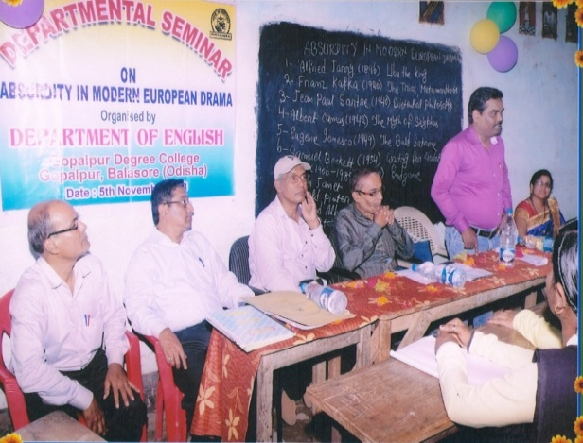
A departmental seminar was organized on 5th November 2018 on “Element of absurdity in European Dharma”. Mr. Akhya Kumar Barik, Lecturer in English from Soro Women’s College attended the seminar as a resource person. Prof. P.C. Datta, H.O.D. of the department inaugurated the seminar and P.K. Mahajan, delivered the keynotes address. 20 participants including students of the department, faculty of others department attended the seminar and took part in deliberation/ presentation. The seminar ended with a vote of thanks offered by Mrs. Swarnmayee Nayak, the lecturer of the department.

Topic : Upanishadam Mahattwam.
Date: 20.12.2018
Resource Person: Mr. Puspendu Das Lect. In Sanskrit.
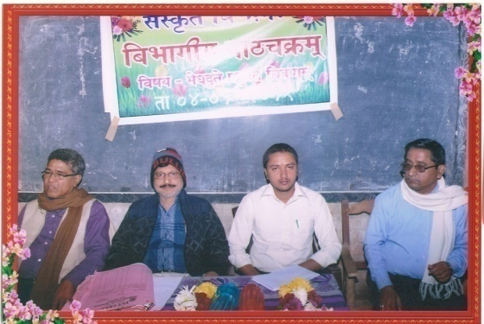
B.C. Sanskrit College, Jageswarpada

42 nos. of students participated in the seminar.
Objective: In order to make students enlighten with knowledge on Upanishads the seminar was organized further, they would learn importance of Upanishadic teachings on human life. They must learn about the aim of human life. Accordingly they would forge their character.
The objective was fulfilled by discussing facts in this seminar.

Topic : Meghadote Prakruti (Nature in Meghadootam).
Date : 04.01.2019
Resource Person: Dr. Jadunath Mishra Ex- Reader in Sanskrit.
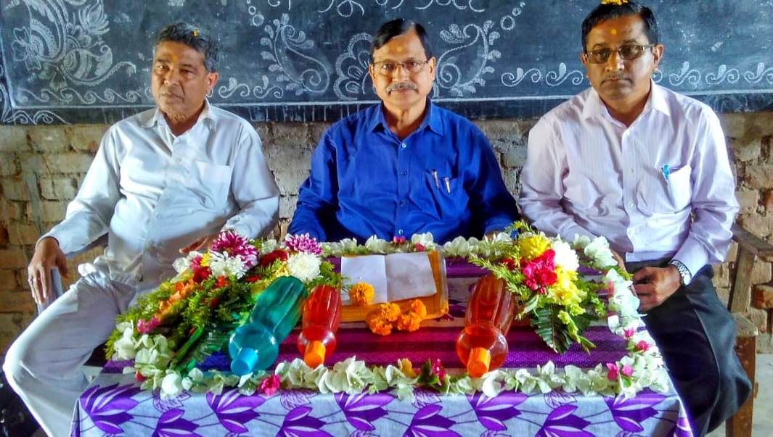
Objectives of the Seminar:- To make the students aware of the natural elements that are useful to human life. To enlighten the students, about Kalidas’s love with nature and natural things. To inculcate a loving attitude in them so that they would depend the natural objects like trees, water, air, woods and the sky. 45 no. of participant remaining in this seminar
The objective was fulfilled with the concluding of the seminar.

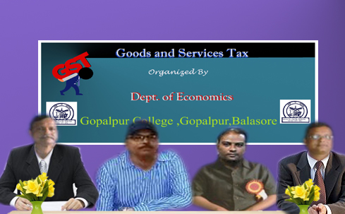
Topic: “GOODS AND SERVICES TAX (GST)”
Date: 20.10.2018
A Departmental Seminar on the topic “GOODS AND SERVICES TAX (GST)” was organised by the Dept. of Economics on date 20.10.2018. The seminar was presided over by the Principal of our College Sri Naresh Kumar Parhi, Sri Bijay Kumar Mohapatra, Lect. in Economics, Shantilata Mahavidyalaya, Uitikiri, and Sri Jagabandhu Barik, Reader in Economics, Simulia College attended the Seminar as a Resource person. 46 no. of students attended the Seminar.

Objectives:
- To make the students aware about GST.
- To improve the information basket about the comparison between past Tax system and GST
- Provide students with opportunities to represent and express their prior knowledge

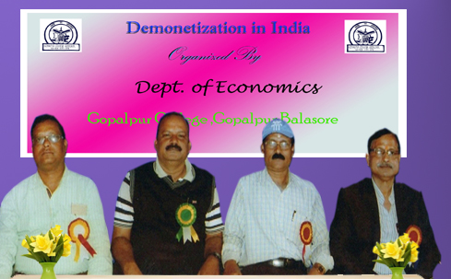
- Topic: “DEMONETISATION IN INDIA” Date: 15.01.2019
A Departmental Seminar on the topic “DEMONETISATION IN INDIA “was organised by the Dept. of Economics on date 15.01.2019. The seminar was presided over by the Principal of our College Sri Naresh Kumar Parhi, Sri Dipti Ranjan Kanungo, Reader in Economics, Dr. J.N. College, Rasalpur and Ananta Prasad Ray, Reader in Economics, Belabhoomi Mahavidyalaya, Avana attended the Seminar as a Resource person. 45 no.s of students attended the Seminar.
Objectives:
- To make the students aware about Demonetization in India and its need.
- To improve the information basket about Demonetization in India and its effects.
- Provide students with opportunities to represent and express their prior knowledge.

- Topic: “Primary Education in Rural Area” Date: 02.11.2018

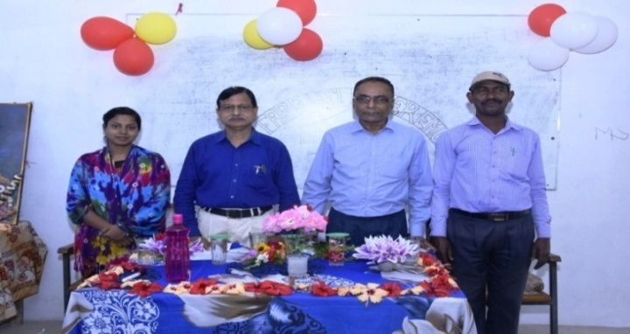
A Departmental Seminar on the topic “Primary Education in Rural Area” was organised by the Dept. of Education on dt 02.11.2018. The Seminar was presided over by the Principal of our College Sri Naresh Kumar Parhi. Sri Maheswar Sahoo, Reader in Education H.K. Mahatab College, Kupari, Balasore attend the Seminar as a Resource person. 40 nos. Students attend the Seminar.

Objectives:
- To improve the Communication language & literacy skills of learner.
- To develop ability for critical thinking & logical judgment.
- To develop awareness and appreciation of the environment.
- To develop individual talent.
Topic: “A programme for Universal Elementary Education in India”
Date: 08.11.2018
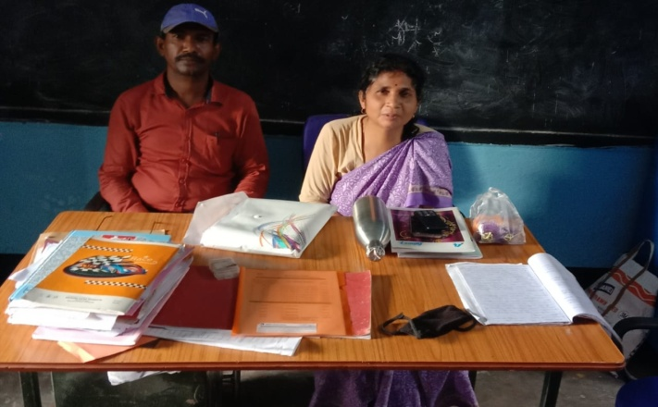
A Departmental Seminar on the topic “A programme for Universial Elementary Education in India” was orgsanised by the department of Education on dt 08.11.2018. The Seminar was presided over by the Principal of our College Sri Naresh Ku. Parhi. Mrs. Anindita Mohanty Lecture in Education of Saraswata Mahavidyalaya Anantapur attends the Seminar as a Resource person. 38 no.s students attend the Seminar.
Objectives:
- A programme with a clear time frame for Universal elementary education.
- A response to the demand for quality basic education all over the country.
- An opportunity for promoting social justice through basic education.
- An expression of political will for universal elementary education across the country.
TOPIC: “Women Empowerment” DATE: 18.09.2018

RESOUCE PERSON:- Bandana Roy, Balasore Mahila College, Balasore

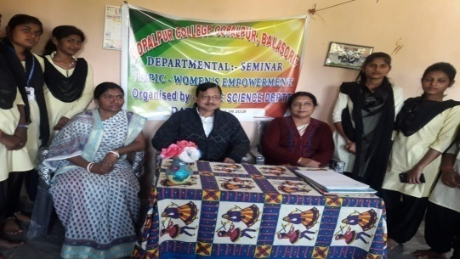
Objectives of the Seminar:
To promote gender equality and the empowerment of women as effective ways to combat poverty, hunger and disease and to stimulate development that is truly sustainable. 24 no.s of student participants in this seminar.

TOPIC: “Hindu Marriage” DATE: 15.02.2019
RESOUCE PERSON:- Bandana Roy, Balasore Mahila College, Balasore

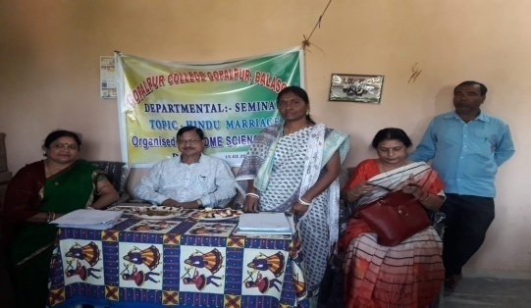
Objectives of the Seminar:
- The religious texts of many communities in India have outlined the purpose, rights and duties involved in marriage.
- Among the Hindus for instance, marriage is regarded as a socio-religious duty.
- 24 nos of student participated in this seminar.

Topic : Regionalism in Indian Politics Date-29-12-2018
Resource Person: Dr. G.S Panda. Principal, Dr. J.N College, Rasalpur, Balasore.

Synopsis:
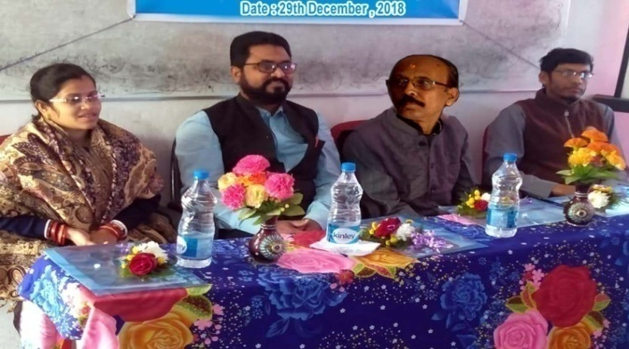
Indian sub-continent is characterized by its cultural plurality. Regionalism is one aspect which is manifested by it. In the context of India, Regionalism is always a ticklish issues and negative perversion. The demand for separate statehood, the demand for Autonomy, the son of the soil policy and the Aggressive Regionalism are the semblances of negative temperament boasting in the wave sub-nationalism. May it be Raj Manohar Committee in Tamilnadu, may it Memorandum of West Bengal left front Government and may it be several contemporary issues, the issue of concern is the unity, integrity and sovereignty of India. These issues are too addressed with utmost national priority. 42 students participated in the seminar of +3 1st, 2nd and 3rd year honours.

Topic : Space wave Propagation
Resource Person : Amar Ballav Panda
Dated : 27.12.2018

Synopsis
Space wave propagation is defined for the radio waves that occur within the 20 km of the atmosphere that troposphere comprising of a direct and reflected waves. These wave also known as troposphere propagation as they can travel propagation as they can travel directly from the earth’s surface. It is also known as line of sight propagation as the signals are sent in a straight line from the transmitter to the receiver.

Application
- It is used in a line of sight communication and satellite communication.
- It is used in a Radar communication.
- It is used in a Microwave lining.
25 no.s of students participated in this seminar.

Topic : Laser and its application
Date: : 12.02.2019
Resource Person : Pravat Ranjan Das

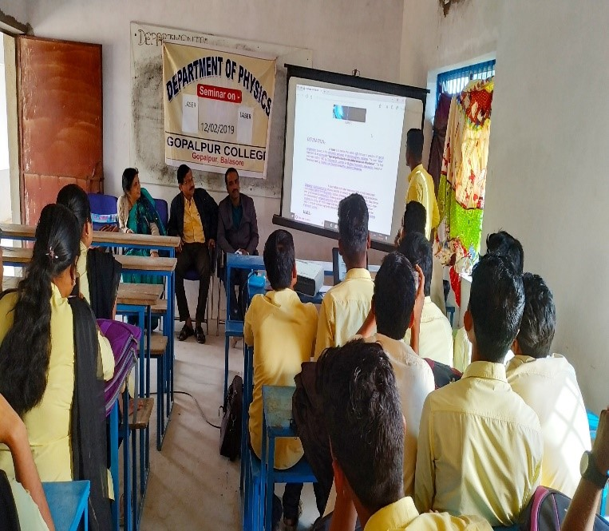
Synopsis
Laser is a device that amplifies or increases the intensity of light and produces highly directional light. Laser hot only amplifies or increases intensity of light but also generates the light. Laser emits light through a process called stimulated emission of Radiation which amplifies or increases the intensity of light. Some laser generated visible light but others generate ultraviolet or infrared rays which are invisible.
Principle
In laser photons are interacted in three ways when atoms that absorption of radiation, spontaneous emission and stimulated emission.
Types of Laser
Laser are classified into 4 types.
- Solid state laser.
- Gas laser
- Liquid laser
- Semiconductor laser.

Application
- Laser in Medicine
- Laser in communications
- Laser in Industries.
25 no.s of students participated in this seminar.

Title : Designing of Fusion reactor, the future solution of Energy Crisis
Dated 10.07.2018
Resource person : Somanath Sahu , Reader in Chemistry
Khaira College , Khaira, Blasore, Odisha
Synopsis:
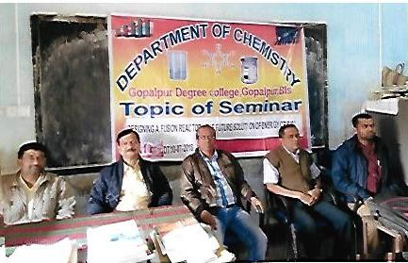
The nuclear fusion reaction generates the energy in the interior of sun. The vision of a power producing fusion reactor based on controlled thermonuclear reaction emerged more than a quarter of a century ago, and the remark able progress has taken place in recent year .un like most of other energy sources ,the fuel available to fusion reactors is almost limitless .fusion reaction involving deuterium and tritium nuclei ,the fuel heated to a temperature ,in excess of 10 million degrees centigrade . At such temperature ,the fuel becomes fully ionized leaving behind a collection negatively charged particles referred as plasma. Nuclear fission proceeds through a chain reaction. The energy available from a fusion reactor is sustainable for the future. 40 no.s of students participated in this seminar.

Date : 07.12.2018
Topic : Save Ozone Layer and Save our Mother Earth
Resource person : Dr. Satyabrata Dash, Reader in Chemistry
U.N. College, Soro, Balasore
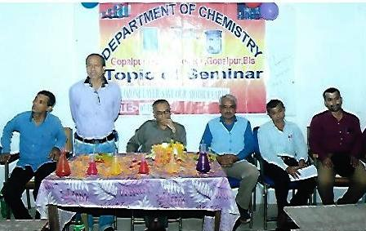
Synopsis:
Ozone layer is a region of earth stratosphere that absorbs most of the Ultra violet radiation. It contains a high concentration of ozone .ozone is the triatomic oxygen atom. Ozone layer was discovered by French physicist Charles Fabry and Henry Buisson. The ozone layer absorbs 97-99% of the U.V. light ,which otherwise would potentially damage exposed life forms near the surface. Ozone
layer was being depleted by chemicals like mainly chlorofluorocarbon .Ozone layer depletion causes the skin cancer in humans and other ecological problems. Ozone layer can be depleted by free radical catalyst including nitric oxide, nitrous oxide, atomic chlorides etc.ozone depleting substance like chloro flouro carbon has a significant positive contribution to the fight against climate change. Ozone depletion is greatest at the south pole. It occurs mainly in late winter and early spring and peak depletion occurs in early October. In 1987, to address the destruction of the ozone layer, the international community established the Montreal protocol on ozone depleting substances .it was the first international treaty to be signed by all countries in the world.
The Seminar is attended by 40 students covering +3 first year and second year and third year Chemistry honors students.
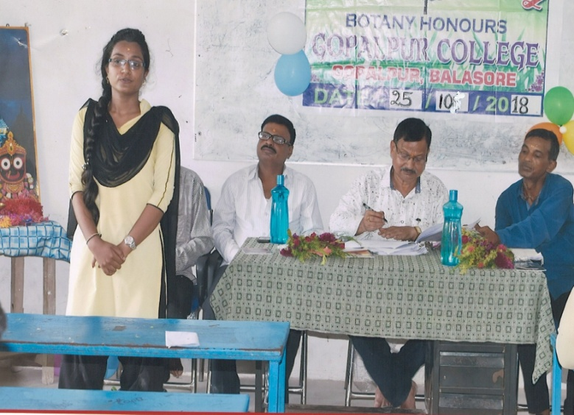
- Topic : STOMATAL MOVEMENT & ABSORPTION OF WATER Date: 25.10.2018
A departmental seminar was organised on 25/10/2018. Tanushree Mohapatra & Pragyanprava Panda present the topic STOMATAL MOVEMENT & ABSORPTION OF WATER. The research person was Dr. Sibanarayan Mohapatra, Proof. in Botany of J.N College Jamsuli, Faculty member took part in the discussion. 34 No of students present in the discussion. Stomata help in transpiration. Transpiration is directly proportional to absorption, ABA causes closure of stomata. The meeting was ended with vote of thanks.
- Topic :- Evolution of coelom Dt. :- 27/12/2018
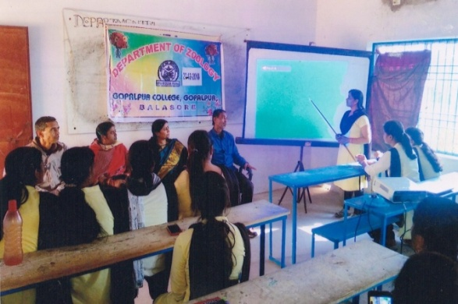
Resource person :- Mrs. Urbasi Jena
Reader In zoology , Nilagiri college,
Synopsis
A body cavity can mean an internal space or series of spaces present inside the body coelom or true body cavity generally refers to a large fluid space. Laying between the outer body wall and inner digestive tube. It contributes directly to the development of excretory reproductive muscular organs of the body.
This seminar helps the students in their future physiological study and field of research. This seminar is attended by 30 numbers of students comprising both +3 1st yr. sc. ,+3 2nd yr. sc. and +3 3rd yr. sc. zoology hons .

Topic: - Oxidation of fatty Acid Dt :- 22/01/2019
Resource person: - Mrs. Swadhina Padhiary
Lect. In zoology , Saraswata Mahabidyalay ,
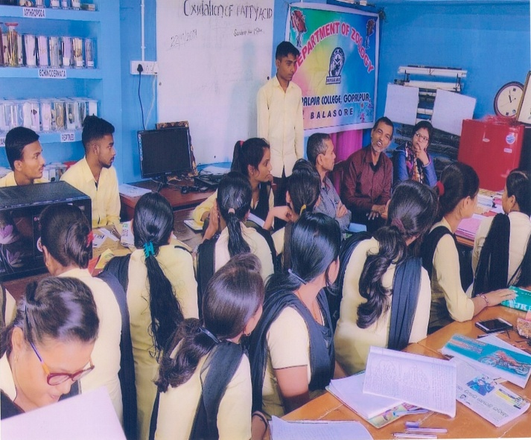
Lipids are a group of naturally occurring organic compounds there are soluble in non-polar organism solvent but soluble in water. They are composed of C, H and O in form of fatty acids and glycerol. Mitochondrial oxidation of fatty acid takes place in the three stages. In first stage in β-oxidation of fatty acid undergo oxidative of successive two carbon in 2nd stage of fatty acid oxidation. The acetyl CoA are oxidized to CO2 in the citric acid cycle . These are also takes place in the mitochondrial matrix. Acetyl CoA derived from glucose via glycol sis and private oxidation.
This seminar will help the students for their future research work and study of biochemistry. This seminar is attended by 28 numbers of students comprising both +3 1st yr. sc. ,+3 2nd yr. sc. and +3 3rd yr. sc. Of zoology Deptt .

Topic-“The Role of Digital Marketing in India” Date- 12.12.2018
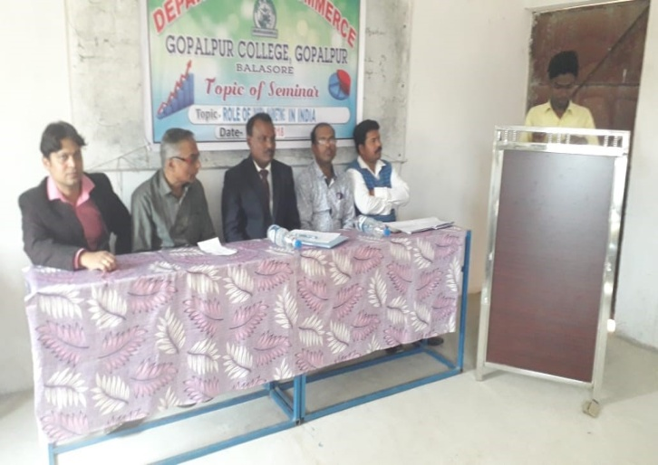

Resource Person: Proff. Bijay Biswal, Upendranath, College Soro, Balasore
Objective of the Seminar
- To promote research activities in commerce
- To enhance ability of Practitioners in field of commerce
- To Learning management of values
- To learn about Digital Marketing
- To Increase knowledge of Emotional Intelligence
- To Increase knowledge of E-Commerce.
85 no.s of students participated in this seminar

Orientation Programme on Library and Information Science
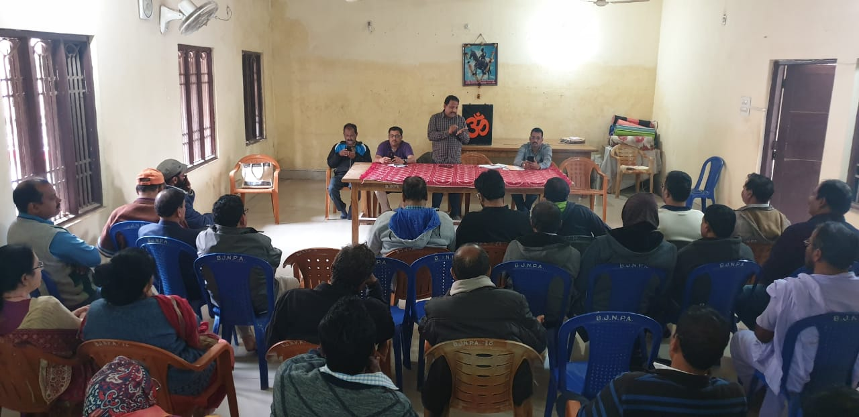
An Orientation Programme on “Library and Information Science” was organized on 03.11.2018 & 04.11.2018 in the Smart Classroom of the college under IQAC Sensitization Programmes. Prof. Naresh kumar Parhi, the principal of the college inaugurated the programme and Major Girish Chandra Sarangi, the Ex. Chief Librarian, Library and Archives of Indian Army joined as the Resource Person of this Orientation Programme. Thirty eight members of participants especially staff of the college joined the programme. Prof. Pravakar Mahajan, Co-ordinator, IQAC of the college introduced the Resource Person and expressed the objectives of such Orientation Programme. Prof. Naresh kumar Parhi, discussed problems relating to library management and book keeping. Major Sarangi discussed the details of Library principles, using library software, library records, digital library and information dissemination. The guiding principles of boosting footfall of the library were also discussed. The normal problems of the library and its eradiation were also highlighted. The questions relating to library management were discussed and its solutions were informed. A vote of thanks was offered to all by Prof. Rabindra Kumar Sahoo.

Work shop on Intellectual Property Right / An Intellectual Discussion
A Work shop on” Intellectual Property Right: An Intellectual Discussion” was organized on 15.11.2018 in Conference Hall. Thirty eight members of the staff participated in the workshop. Prof. Naresh kumar Parhi, principal of the college inaugurated the programme. Dr. Surendra Panigrahi, Reader, U.N. College Soro and Mr. Kirti Ranjan Pattanayak, Lecturer A.B. College, Basudevpur addressed the participants as Resource Persons. The Resource Persons highlighted on nature of innovative concepts such as patent, trademark, trade name, industrial designs, trade dress, service marks, trade secret and trade models. The subject regarding copyright of any innovative product, research products or intellectual application and its objectives of protection, infringement and utility are discussed on the workshop. The moral aspects in protection of intellectual property are also highlighted. The participants shared questions on misappropriation and enforcement of intellectual property laws. The workshop was concluded with a vote of thanks to all by Prof. Biswanath Sahoo.
Symposium on Adolescent Behaviors and social crime
DATE: 23.10.2018
A Symposium on “Adolescent Behavior and Social Crime” was organized on 23.10.2018 at conference Hall of the College. Prof. Naresh Kumar Parhi , The Principal of the college inaugurated the symposium , L.N. Urmila Das , the Secretary , Lions Club, Balasore , L.N. Puspa Das , the members of , Lions Club, L.N.G. Babita , the members of , Lions Club and Prof. Rabinarayan panda ,Principal , Balasore Law College , Balasore ,attended the symposium of Resource Person, sixty seven participants including the employees and students of the college attended the Programme. The resource person highlight on juvenile behavior and adolescent activity of the young mass. They feel charm of committing a lot crime due to immature mind and emotional engagement. The social families are teaching act upon their goodness and soberness in manners dealing. Prof. Rabinarayan Panda discussed about different crimes generally committed by young children .He also gave an account of the provision of punishment inflicted upon juvenile crimes for their amendment in behavioral and criminal attitude. The role of education in this respect is highly affective to in fuse goodness and refinement in children’s activities. The symposium comes to end with a vote of thanks by Miss Anita Jena, the Programme officer of N.S.S. Unit.
Workshop for Digital India for Women
Date: 12.11.2018
A Workshop on “Digital India for Women” was organized on 12.11.2018 by Employment Information Cell of the college. Thirty nine students and Employees attended the Programme. Prof. Naresh Kumar Parhi , the Principal of the College inaugurated the Workshop. Prof. Kamalakanta Acharya , the Director, Academy of Business Administration(ABA) and Prof. Sanjay Kumar Panda , Head of the Department, academy of Business Administration joined as a Resource person of the workshop. Thirty nine students and Employees attended the Programme. The Resource person explained the Government policy to digitalize India to quick , correct and convenient correspondence. The emphasized on the role of women to handle the digitalization, animation and computerization process. They also enumerated in cases in which the women, by nature patientful, can handle the E-Programme carefully. Moreover, the same can give scope to engage women in services and boost up their incomes. Further, the digitalization can help for proper free works, better storage, retrieving and sharing the information in quickest and easiest possible time efforts and money. The knowledge was stored in form of questionnaire and doubt clearing interaction ,The workshop came to a close after a vote of thanks to all given by Prof. Snehalata Tripathy, the in-charge-officer of Employment Information and Career Counseling Cell.

